## Merchant Name: Tennr Implementation POC: Royce *(IM to fill)* CX POC: *[IMP to Add]*

### 

### 

| Notes Sections   *(AE to fill if they have, Implementation to be completion DRI on handoff)*   * Info on how merchant bills   - Implementation (one time) - Subscription- flat fee (min commit) 5-6 different products: - document intake (# of intakes) - Benefits (# of verified transactions) - unique payment terms - not charging for overages right now  1) What is the merchant temperament?  -Enrique will be the main contact. He is a very detailed and straightforward person. Relatively laid back but very sharp.  -Matthew is their owner of SFDC. We did not meet with him during the sales process.  - Their external accounting will be the day-to-day operators of Tabs. I am unsure who their other client is but someone else they support uses Tabs today.  3) What are the Tabs features that the key POC cares about?   * SFDC integration * QB integration * Stripe integration * Reporting |
| --- |

### Billing model *(Entire Section: Implementation to fill section)*

* Are there unique things about the customer creation process for this merchant?
* Information on how merchant bills
* How contract is broken up
* One off things to know about the merchant

Contract Processing Steps  
*(Entire Section: Implementation/Success to fill Post-Go Live)*

### **General Rules**

* Add billing information to customer
* If the “Add-on” agreement doesn’t have a stated end date - refer to the previous contract and use that end date
* For professional services products (implementations), for rev rec, months of service = 12 months regardless if it’s a multi year contract

### **Locate Billing Terms**

* Billing terms appear in the pricing tables of the Order Form (generally labeled by year)
* Process each item listed under the pricing section (e.g., Platform Fee, Implementation Fee, Usage-based items) as a separate BT
* For multi-year products, these can be combined into one BT if the price and quantity are the same 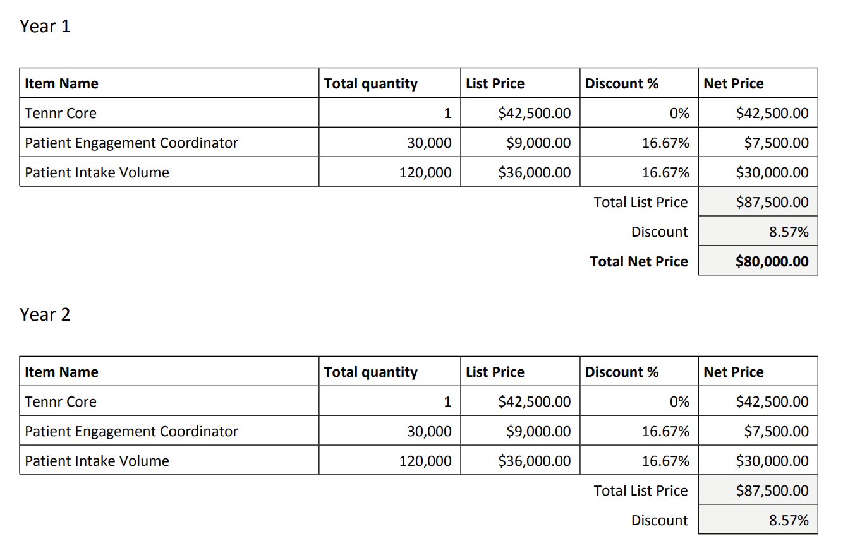

### **Item Name**

* Use the stated product/service name
  + Examples: "Tennr Premium Plus", "Patient Intake Volume", "Provider Engagement Coordinator", “Base Platform Fee”
  + Try and keep the naming conventions consistent:
    - If the product name in the contract is ‘managed services’ or ‘professional services’ use  **Implementation Fee** as item name

### **Item Description**

* Use the specified unit quantity, if stated. Otherwise default to 1
  + Example below - items circled in pink would be the item description



### **Integration Item**

* Mark integration item for all BT: Sales

### **Quantity**

* Use the quantity listed for each line item (e.g., 25,000 Qualification Checks, 1,700 Runs) and divided by the billing frequency if the quantity is a per year quantity
  + **Billed Quarterly -> divide annual net price by 4**
  + **Billed Monthly -> divide annual net price by 12**
  + Example:
  + 
  + 
    - 408,000 / 4 = 102,000
  + 
  + 
    - Document Wrangling -> 22571 * 12 = 270852
    - Intake -> 22571 * 12 = 270852
* If no quantity is specified (e.g. Implementation Fee or Platform Fee) default Quantity to 1

### **Price**

* Use the price listed for each line item - if there is a discount, use the “net price” and divide by the billing frequency if the price is a per year price
* Normalize prices to the cadence you need:
  + **Billed Quarterly -> divide annual net price by 4**
  + **Billed Monthly -> divide annual net price by 12 or multiply**
  + **Billed Annually -> multiply monthly price by 12**
  + Example:
  + 
    - $28,350 / 4 = $7,087.50
  + 
  + 
    - Tenner Platform Fee -> $4,000 * 12 = $48,000
    - Document Wrangling -> $18,41.79 * 12 = $22,101.48
    - Intake -> $19,27.56 * 12 = $23,130.72
* If price is $0 due to 100% discount or waived period, still process the BT and set price to 0

### **Months of Service**

* Use the term of the contract (e.g., 29 months, 12 months)
* Revenue is still recognized in free months so in the example below:
  + You would have to create BT for each product in each pay period
  + Months of service for the first pay period is 18 (7/31/2025 - 1/30/2027)
    - Billing ends 7/30/2026 (4 periods at 3 month frequency for quarterly)
  + Months of service for the second pay period is 12 (1/31/2027 - 1/30/2028)
  + Example contract: ac4022a7-b8ae-40f8-be91-7006602bed43



### **Service Start Date**

* Use stated start date

### **Billing Start Date**

* Use the "Contract Start Date" unless there is a stated waived/complimentary period
  + Example: If service starts Aug 25 but fees waived through Jan 24, use Jan 25 as Billing Start Date
  + Free periods can be calculated by looking at the months of service
    - Full terms are 1 year (12 months)
    - 
      * 29 months -> two full years will be 24 months -> 29 - 24 = 5 months free
  + **Determine when the free periods are** 
    - Sometimes it says billing starts on X date, and if that X date is when the contract starts, then the free period is at the end
    - For future contracts, Tenner is pushing to standardize free months at the start going forward

### **Frequency**

* Use frequency based on stated billing cadence:
  + Quarterly = Quarterly
  + Annually = Annual
  + One-time implementation fees = None
* Implementation Fee = same frequency
* *Note! Please pay attention to “Implementation Fee” products*
  + *Sometimes, there will be a specific billing cadence stated (example below). If nothing is stated, follow the billing frequency of the other BT*
  + 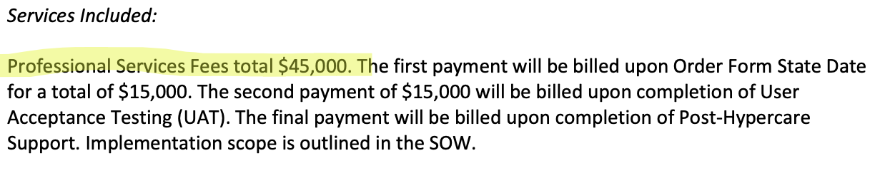

### **Net Terms**

* Use terms listed under "Payment Terms" (e.g., Net 30)
* If not listed, default to Net 30

### **Ignore**

* **For now we are ignoring overages**

### **Edge Case**

[Nationwide](https://garage.tabsplatform.com/prod/contracts/26f59573-bc78-40da-9075-62209be7d21b/terms/revenue)

* **Different pricing for different pay periods**
* 3 years, 6 months free
* Billed quarterly
* 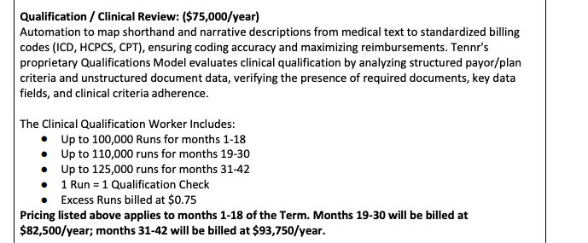
  + Months 1 - 18 -> $75k a year / 4= $18,750
  + Months 19 - 30 -> $82,500 a year / 4 = $20,625
  + Months 31 - 42 -> $93,750 / 4 = $23,437.50

### Events Processing (if necessary) *(Entire Section: Implementation/Success to fill Post-Go Live)*

* Any important information on events billing

Integration Items Processing (if necessary)  
*(Entire Section: Implementation/Success to fill Post-Go Live)*

* What are the instructions for assigning integration items?
* Example: All Statsig integrations items should be labeled as “Sales”
* Example: All “Pinata” integration items should be labeled as “Software Subscription Bundle” unless otherwise noted by Merchant

Post Processing Communications (if necessary)  
*(Entire Section: Implementation/Success to fill Post-Go Live)*

* Does the Ops Team need to notify anyone on the team re: completion of processing batches in Implementation or Active phase?
* Who needs to be notified and when?
  + Example:
    - Who: Customer Success [Azmat Aziz] needs to be notified
    - Where: Messari internal merchant channel
    - When: contracts are processed [Merchant Phase: Active]

### Customer Information *(Entire Section: Implementation/Success to fill Post-Go Live)*

* Any important information on specifics customers of this merchant
  + Special memo’s certain invoices require
  + Invoice changes due to merchant/customer relationship

### Feature Requests *(AE to fill for all requests prior to Imp handoff, Imp to fill prior to go-live/Success to fill to fill Post-Go Live)*

* Enrique is very excited and interested in our AI agents
  + What is it - AI agents
  + Why it's important - They are also an AI company. Since Enrique also does not sit in the pain today these agents are ways for the process to be automated as they move the function in house
  + Urgency - low to medium. Ali H. shared with him the current state and vision of AI at Tabs

### Merchant Calls *(AE to fill for all videos prior to Imp involvement, Imp to fill prior to go-live/Success to fill to fill Post-Go Live)*

* [July 9th](https://us-56595.app.gong.io/call?id=7220971677460844200) - Demo
* [July 10th](https://us-56595.app.gong.io/call?id=389589278248332330) - Pricing / implementation & CX
* [July 16th](https://us-56595.app.gong.io/call?id=4633575343588059984) - Ali chat
* [July 17th](https://us-56595.app.gong.io/call?id=665313370515172775) - Tabs custom demo
* [July 24th](https://us-56595.app.gong.io/call?id=5930245741901450026) - check in on decision & timeline
* [July 28th](https://us-56595.app.gong.io/call?id=5043516443028964841) - Go / no go